Google Corporation®
Belgrave House,
76 Buckingham Palace Road,
London SW1W 9TQ,
United Kingdom.

GOOGLE AWARD NOTIFICATION

Ref NO: GCS/G6I/88809
Batch: GUK/679/33/097I
We wish to congratulate you once again on this note, for being part of our winners selected this year. This promotion was set-up to encourage the active users of the Google search engine and the Google ancillary services. Hence we do believe with your winning prize, you will continue to be active and patronage to the Google search engine. Google is now the biggest search engine Worldwide and in an effort to make sure that it remains the most widely used search engine, we ran an online e-mail beta test which your email address won £950,000.00 GBP {Nine Hundred and Fifty Thousand Great British Pounds Sterling}.

A winning Cheque will be issued in your name by Google Promotion Board, and also a certificate of prize claims will be sent along side your winning Cheque. In your best interest to avoid mix up of numbers and names of any kind, we request that you keep the entire details of your award strictly from public notice until the process of transferring your claims has been completed, and your funds remitted to your account. This is part of our security protocol to avoid double claiming or unscrupulous acts by participants / non participants of this program. Kindly fill-in the verification and fund release form below.

VERIFICATION AND FUNDS RELEASE FORM.

(1) Your contact address:
(2) Your Tel/Fax numbers:
(3) Your Nationality/Country:
(4) Your Full Name:
(5) Sex:
(6) Occupation:
(7) Age:
(8) Ever won an online lottery?

Please contact your claims agent immediately for due processing and remittance of your prize money to file for your prize claim, kindly contact your CLAIMS agent.

CONTACT CLAIMS OFFICE:

Google Promotion Board
Dr. Brian Robinson
Email-: mrbrianrobinson77@yahoo.co.jp
Tel: +44 704 2065 414

NOTE: For easy reference and identification, find below your reference and Batch numbers. Remember to quote these numbers in every one of your correspondence with your claims agent. Ref NO: GCS/G6I/88809, Batch: GUK/679/33/097I.

Congratulations once again from all our staff and thank you for being part of our promotions program.

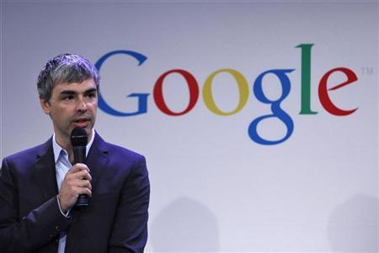
Lawrence Page
Chairman of the Board and Chief Executive Officer.
©2013 Google Corporation.

