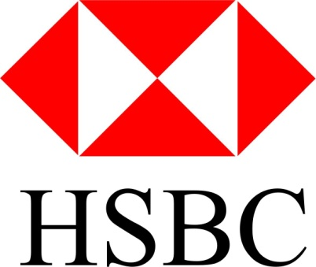
HSBC BANK 2017 COMPENSATION
From Foreign Payment Director
HSBC BANK, SOUTH AFRICA
Email: compensation2015@consultant.com
Attn:
SCAMMED VICTIM/1MILLION BENEFICIARY.REF/PAYMENTS CODE: 06654 1MILLION USD
This is to bring payments of your $1 Million
Compensations funds.
On these faithful recommendations, I want you to know that during the last UN meetings held at SOUTH AFRICA, it was alarmed so much by the rest of the world in the
Meetings on the loose of funds by various foreigners to the scams artists operating in syndicates all over the world today. In other to retain the good image of the
Country, the South African government is now paying 100 victims of this operators $1 Million USD each.
According to the number of applicants at hand, 80 beneficiaries has been paid ,half of the victims are from the United States, we still have more 20 left to be paid the
Compensations of $1 Million each.
Your particulars was mentioned by one of the syndicates who was arrested in South Africa as one of their victims of the operations, you are hereby warned not to
to your notice that I am delegated from the United Nations to HSBC BANK of SOUTH AFRICA to pay 100 Nigerian 419 scam victims $1Million each, you
Are listed and approved for this payments as one of the scammed victims, get back to us as soon as possible for the immediate
Communicate or duplicate this message to him for any reason what so ever, the US secret service is already on trace of the criminal.

You can receive your compensations payments via any of the both options you choose, DRAFT, PAYMENTS or WIRE TRANSFERS.
I shall feed you with further modalities as soon as I hear from you at my private email address: (compensation2015@consultant.com)
Yours faithfully,
Mr W. Ben

