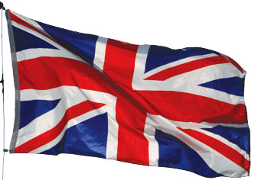 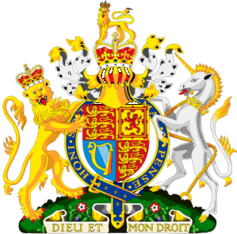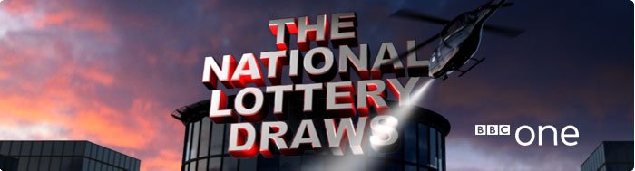  [](http://www.google.co.in/imgres?imgurl=http://www.fromthevaultradio.org/home/wp-content/images/FTV%20191%20From%20the%20Vault%20on%20the%20BBC/bbc-logo.jpg&imgrefurl=http://fromthevaultradio.org/home/2010/01/01/ftv-191-from-the-vault-on-the-bbc/&h=360&w=450&sz=14&tbnid=Z7G5fsyh3vnNlM:&tbnh=102&tbnw=127&prev=/images?q=bbc+logo&zoom=1&q=bbc+logo&hl=en&usg=__7TbdOuHi-c8yu7P2YMgaciHGl60=&sa=X&ei=zFDSTKvYMYLKvQO2msHRDw&ved=0CB4Q9QEwAA)

**BBC One National Lottery Team**

**National Lottery Draws Results.**BBC INTERNATIONAL LOTTERY CENTER NO: 768 DERRY WAYN WNT.  
LONDON. ENGLAND**.**

** Tel: +447017430096**

**Visit Our Web Site:**  [**www.bbc.co.uk/lottery/**](http://www.bbc.co.uk/lottery/)

**Winning No: 1654**

**BBC LIVE DRAW WINNER NO. (06) (16) (26) (32) (34) (46) BONUS (33)**

**This is to inform you that you have WON the sum of £500.000.00 Pounds from our 2012 charity bonanza. The draw winning no. 1654 brought out your e-mail address from a Data Base of Internet Email Users and qualified you a benefited winner of the stated winning amount, in the ongoing £44.4million Spring lottery charity bonanza for UK London's heritage,**

**Held on the 2012. The BBC National Lottery Fund gives grants to sustain and transform individual lives all over the globe for the less privilege once; we are here to use our diverse heritage to change lives in every part of the global world.**

**Please send your draw winning no 1654and Fill the Information below and Send to claims department Via E-mail :(** **bbclive2020@live.co.uk)**  
**1. You’re Name……  
2. Your Father’s Name.....  
3. Your Mother's Name........**

**4. Your Wife Name if married…**

**5. Your Husband Name if Married…  
6. Your Home Address...   
7.Country/  
8.State.  
9. Mobile No...  
10. Sex...   
11.Age...   
12.Occupation.**

**13. Email…**

**13. Annual Income…**

**15. Scan copy of your Identification (Driving License or any Valid I.D Proof) Needed.**

**Yours sincerely,**

**Claims Manager   
Dr Tom Wilson**

** Tel: +447017430096**

**Email:** bbclive2020@live.co.uk**Visit Our Web Site:** [**www.bbc.co.uk/lottery/**](http://www.bbc.co.uk/lottery/)

Awarding funds from The National Lottery

[](http://www.bbc.co.uk/bbcone/)

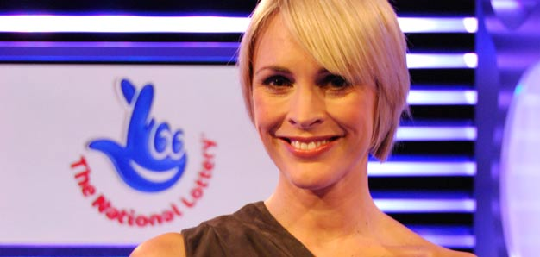

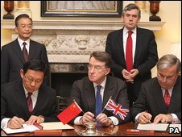[](http://www.google.co.in/imgres?imgurl=http://www.fromthevaultradio.org/home/wp-content/images/FTV%20191%20From%20the%20Vault%20on%20the%20BBC/bbc-logo.jpg&imgrefurl=http://fromthevaultradio.org/home/2010/01/01/ftv-191-from-the-vault-on-the-bbc/&h=360&w=450&sz=14&tbnid=Z7G5fsyh3vnNlM:&tbnh=102&tbnw=127&prev=/images?q=bbc+logo&zoom=1&q=bbc+logo&hl=en&usg=__7TbdOuHi-c8yu7P2YMgaciHGl60=&sa=X&ei=zFDSTKvYMYLKvQO2msHRDw&ved=0CB4Q9QEwAA)

**UK BBC LOTTERY SPONSOR’S 