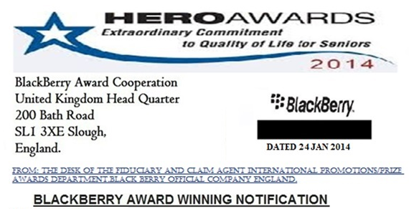
Attention BlackBerry Winner
IN: bb/25/08/PAY-2.5
Winning Amount: $1,860,000.00.
BlackBerry Q5 Mobile Phone

CONGRATULATIONS/HAPPY NEW YEAR TO YOU AND TO YOUR FAMILY. FROM BLACKBERRY OS ANDROID 2014 AWARD

Congratulations! This is to announce to you that you have won BlackBerry award. You Have Won One Million Eight Hundred And Sixty Thousand US Dollars ($1,860,000) and a BlackBerry Q5 Smartphone from BlackBerry 2014 Global Market Award Promotion. We the BlackBerry Rim Limited has come together to bring all smart phones together to be able to communicate through BlackBerry Massager on all Android Supporting Mobile Phone. A new great Benefit to your mobile Smartphone is that you can ping BlackBerry Phones with any mobile having Android supported phone.

This message may come into your SPAM FOLDER but be informed that This notification and your award is %100 real and legal. You are a through winner.

Your PAYMENT ATM MASTERCARD of One Million Eight Hundred And Sixty Thousand US Dollars ($1,860,000) and BLACKBERRY Q5 is available for delivery to your address, to validate the delivery, please contact us immediately and provide us your full details below to book the shipment to you at your address.

Provide the following:

Payment Order: Indemnity of BlackBerry Treasury 0007832434-Bond Account.
YOU ARE REQUIRED TO FILL THE FOLLOWING DETAIL
1. Full name: ………………..
2. Residential Address: ………………………
3. Date Of Birth: ……………………………
4. Phone Number……………
5. Occupation: …………………..
6. State: ………………………….
7. Country: ……………………

Send us the required information for immediate DISPATCH of your winning to you. Shipment invoice comprehensive details will be sent to you immediately we receive delivery requirement.

Our paying bank has loaded your winning money ($1,860,000) into your ATM MasterCard, Payable in any of the ATM Machine in your country.

CALL MR. MAJ HOLLYBRAIR ON THE FOLLOWING CONTACT NUMBER FOR ANY QUESTION REGARDING CLAIMS/PAYMENT: +447010042593
