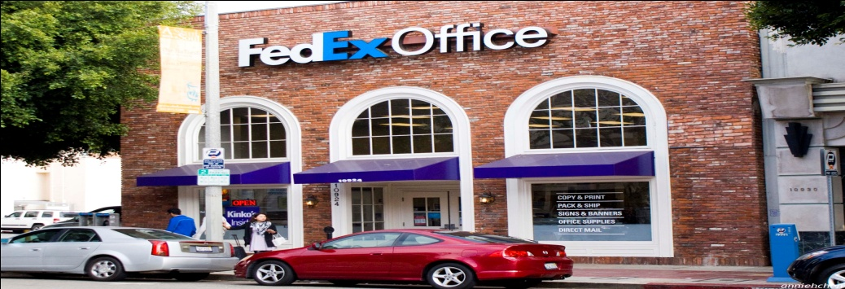

Dear Valuable Customer,
We have been expecting you to contact us for your long existing Package that was registered with us for shipment to your residential location. We thought that the UK National lottery board gave you our contact details to contact us, it may interest you to note that a letter was also added to your FedEx package, however we cannot read the full content to you via email for privacy/security reasons we understand that the package itself is a winning bank Cashier cheque which worth over $1,500.000.00 USD {ONE MILLION FIVE HUNDRED THOUSAND UNITED STATE DOLLAR} As you may know the FedEx Delivery Express Service world-wide do not ship money in CASH but Bank Drafts/winning cheques are shippable. The package is registered with us for mailing by the UK National Lottery Promotion Board, We are sending you this email because your package is been registered on a Special delivery Order on our desk by (U.K NLB). What you have to do now is to contact our Delivery Department for immediate dispatch of your package to your residential address in your country.
Note that as soon as our Delivery Team confirm your information's it will only take two working days (48hours) for your package to arrive your designated address. For your information, the VAT & Shipping charges as well as the Insurance fees have been paid by the UK National Lottery Board, before your package was registered. Note that the payment that is made on the Insurance, Premium & Clearance Certificates, is to certify that the winning cheque is not for Drug Affiliated Fund (DAF) neither is it a fund to sponsor Terrorism in your country. This will help you avoid any form of query from the Monetary Authority of your country. Note that you will have to pay total Security fees of $221 USD to the FedEx Security Company India being full payment for the Security Keeping Fee of your package as stated in our privacy terms & conditions page. Also be informed that the UK National Lottery Promotion Company wishes you to pay for the Security Keeping charges, but we do not accept such payment just like that considering the fact that all items & packages that is registered with us have a time limitation and we cannot accept payment that is not known to us, so you are to send us your full detail so we can furnish you with our own payment procedures for the security keeping fee of your parcel containing $1,500,000.00 USD.
Kindly note that the lottery promotion did not leave us with any further information we hope that you respond to this mail as urgent as possible because if you fail to respond until the expiry date of this package, we may refer the package to the British Commission for Welfare as the package do not have a return address.
Kindly contact the delivery department (FedEx Delivery Post Office India) with the details given below:
FedEx Delivery Post Contact Person: Mr. Bright Wilson
INDIA Office Tel: +918- 447-141-708
Email: Fedexe9@outlook.in
kindly complete the below form and send it to this email address Fedexe9@outlook.in
This is mandatory to reconfirm your Postal address and telephone number before we can commence on your delivery.
-------------------------------------------------
FULL NAMES:
CONTACT ADDRESS:
TELEPHONE NUMBER:
CITY:
STATE:
COUNTRY:
OCCUPATION:
SEX (M/F):
AGE:
STATE OF ORIGIN:
-------------------------------------------------
kindly complete the form and send it to this email address: Fedexe9@outlook.in
As soon as your details are received, our delivery team will give you the necessary payment procedure so that you can remit the payment for the Security Keeping Fees. As soon as your payment of $221 USD for the security keeping fees is received and confirmed, our delivery team will not hesitate to dispatch your package as well as the attached letter to your residential address. It usually takes 48 hours being an over nights delivery service. Get back immediately with your information’s so we can proceed with this mission.
Regards
Mr. George Ramnnut
General Manager
FedEx Online Team Management
E-Mail: Fedexe9@outlook.in

