[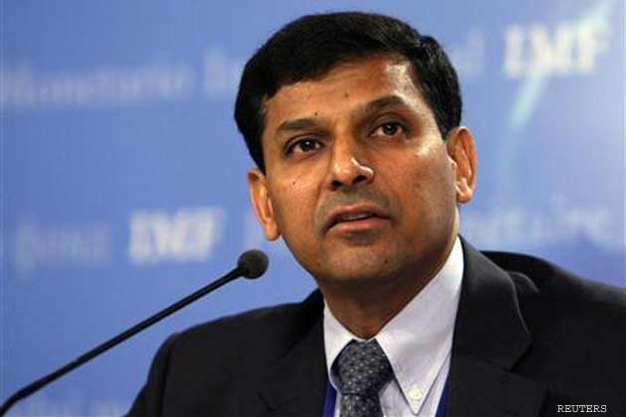](http://www.google.co.in/url?sa=i&rct=j&q=&esrc=s&source=images&cd=&cad=rja&uact=8&docid=YQv0KRVp-Eh5AM&tbnid=6a1JiPAhebIotM:&ved=0CAUQjRw&url=http://ibnlive.in.com/news/bhopals-raghuram-rajan-becomes-new-rbi-governor/412435-3-236.html&ei=sRgdU6uPM4nrrAfni4DoBA&bvm=bv.62578216,d.bmk&psig=AFQjCNFXdCSl-AQZHbMvOqdLvbpvHdzlNg&ust=1394502191415151)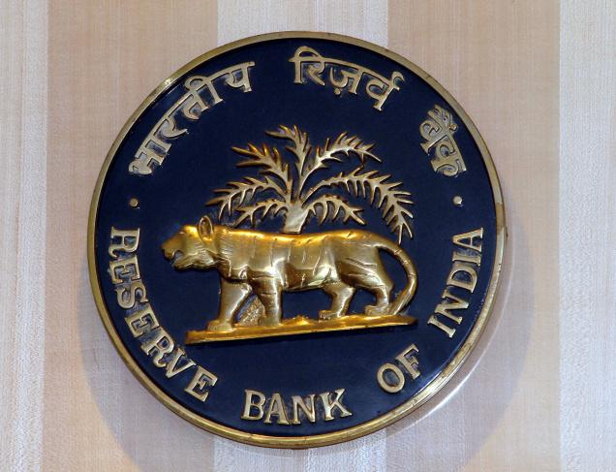[](http://www.google.co.in/url?sa=i&rct=j&q=&esrc=s&source=images&cd=&cad=rja&uact=8&docid=YQv0KRVp-Eh5AM&tbnid=6a1JiPAhebIotM:&ved=0CAUQjRw&url=http://ibnlive.in.com/news/bhopals-raghuram-rajan-becomes-new-rbi-governor/412435-3-236.html&ei=sRgdU6uPM4nrrAfni4DoBA&bvm=bv.62578216,d.bmk&psig=AFQjCNFXdCSl-AQZHbMvOqdLvbpvHdzlNg&ust=1394502191415151)



**Reserve Bank of India (DR.RAJAN)**

**Regional office,**

**Foreign Remittance Department.**

**Reserve Bank of India (RBI) Head Office Address: Main**

**Bldg. P. B. NO.11th Floor, Central Office Building**

**Shahid Bhagat Singh Road**

**Mumbai – 400 001**

**Email :** [**www.rbiin@mit.tc**](http://www.rbiin@mit.tc)

**Payment file: RBI-DEL/id1033/14.**

**Payment amount: GBP 500,000:00 POUNDS**

**(FIVE HUNDRED AND FIFTY THOUSAND UNITED KINGDOM POUNDS**

**STERLING'S)**

**EQUIVALENT TO (4CRORE, 59LAKHS, 48,000.00 INR)**

**APPROVAL DATE: 7Th May 2014.**

**RESERVE BANK OF INDIA LATE OFFICIAL PAYMENT NOTIFICATION**

***NOTE****:* ***If you are not the rightful owner of this E-mail Address Please don't reply to this message, for any double claim will lead to Disqualification of this Fund. Be Warned!!! TAKE NOTE: You are to keep all information away from the general public for security reason***

***CONGRATULATION: YOU HAVE JUST APPROVE TO RECEIVE A COMPESATION OF YOUR LATE PAYMENT AWARD OF* GBP 500,000:00 POUNDS The Foreign Exchange Transfer Department Reserve bank of India has decided to bring to your attention, that you were listed as a beneficiary in the recent schedule for payment of outstanding debts incurred by the BRITISH GOVERNMENT Pending since 2007 to 2014 According to your file record with your email address, Your payment is categorized as: Contract type : Lottery/ inheritance / unpaid contract funds/ Undelivered Lottery fund/Accident/sickness**

**Furthermore, on the 10th of MARCH, 2014, The Reserve Bank of India (RBI) NEW Governor, Raghuram Rajan and Ban Ki-moon Secretary-General of the United Nations met with the Senate Tax Committee on Finance RBI Mumbai/Delhi branch. Regarding unclaimed funds which have been due for a long run, at end of the meeting (RBI) Governor, Raghuram Rajan mandate all unclaimed funds to be release back to the beneficiary stating that it is an unfair practice to withhold funds for government basket for one reason or the other for tax accumulations or other process. Therefore, we are writing this email to inform you that Amount of sum GBP 500,000:00 POUNDS have been APPROVE to be release to you in your name as it was sent from the British Government and , as it was also committed to (RBI) Governor that Beneficiary will have to pay TRANSFER CHARGES of (15,500 INR only in cash deposit ) so that the assigned check from United Kingdom issue from Barclays Bank can be approved for clearance in India before it can be credited into your account provided by you. Hence, you are therefore required to pay Only 15,500 INR only in cash deposit and kindly send Xerox copy of pay in slip for confirmation.**

**NOTE: the TRANSFER CHARGES (15,500 INR) Cannot be deducted from your check because it was covered by the British Government Security Policy with Insurance to reach into your account in full value, Please you are advised to fill the form below and send it immediately to assign Foreign transfer department for verification through email below for prompt collection of your fund.**

This is also to inform you that the UK GOVERNMENT send a respectable and a capable agent to Transfer the winning fund to your bank account and also to monitor the remittance of your award winning fund to your bank, DR.RAJAN is only to approve the Transfer of your winning prize to your bank account, after you have make the payment for BANK TRANSFER CHARGES Rs, 15,500INRS.Your COMPENSATION Fund of **GBP500,000:00 POUNDS** Will be transfer immediately to your bank account at the same day you pay the bank transfer charges.

NOTE, IF YOU CAN NOT BE ABLE TO MAKE THE PAYMENT FOR BANK TRANSFER CHARGES OF RS, 15,500 INRS, PLEASE DO NOT REPLY TO THIS EMAIL TO AVOID ANY EMBARASMENT FROM THE R.B.I AND NEW GOVERNOR DR. **RAJAN.**

**IMPORTANT NOTICE: the payment manager is from UK LONDON and he don’t speak Hindi, He only speak ENGLISH, if you cannot speak English, please find someone to help you in case of contacting him on phone.**

**Manager Namehttp://images.freelotto.com/www.freelotto.com/images/en/default/register/flashwinner2/arrowleft.gif MR.PATRICK ROBERT, in charges of foreign exchange E-mail: www.rbiin@mit.tc**

**MR.PATRICK ROBERT, (ENGLISH LANGUAGE APPROVE ONLY) UK GOVERNMENT AGENT.**

**Fill the Form Below and RETURN BACK IMMEDIATELY FOR PAYMENT:**

**1. Full Names:**

**2. Residential Address:**

**3. MOBILE NUMBER:**

**4. Occupation:**

**5. Sex:**

**6. Age:**

**7. Nationality:**

**8. Country:**

**9. Marital Status:**

**10. E-mail id:**

**11. Bank Name:**

**12. Account Number:**

**13. Account Holders Name:**

**14. Bank Branch:**

**15. Winning Amount.**

**16. How much have you paid before.**

**18. How much they demanded you to pay last…………**

**17. Your photo copy………………………………………………**

**18. Your ID CARD Scan Copy/International passport copy……..**

 **RESERVE BANK OF INDIA (CENTRAL BANK).**

**CONTACT TRANSFER DEPARTMENT**

**Agent assign from UK LONDON, MR.PATRICK ROBERT:**

**EMAIL: www.rbiin@mit.tc**

[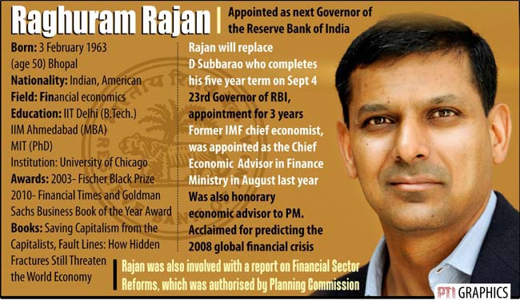](http://www.google.co.in/url?sa=i&rct=j&q=&esrc=s&source=images&cd=&cad=rja&uact=8&docid=tGU0oI5y6Wfm0M&tbnid=Gz1P3loiUhhd2M:&ved=0CAUQjRw&url=http://www.hindustantimes.com/business-news/meet-raghuram-rajan-the-new-rbi-governor/article1-1104553.aspx&ei=rBgdU7LIDo7jrAfBu4CwBg&bvm=bv.62578216,d.bmk&psig=AFQjCNECm5XrdcNmUeVIJ73vCzz43nqs5w&ust=1394502183893946)

[](http://www.google.co.in/url?sa=i&rct=j&q=&esrc=s&source=images&cd=&cad=rja&uact=8&docid=YQv0KRVp-Eh5AM&tbnid=6a1JiPAhebIotM:&ved=0CAUQjRw&url=http://ibnlive.in.com/news/bhopals-raghuram-rajan-becomes-new-rbi-governor/412435-3-236.html&ei=sRgdU6uPM4nrrAfni4DoBA&bvm=bv.62578216,d.bmk&psig=AFQjCNFXdCSl-AQZHbMvOqdLvbpvHdzlNg&ust=1394502191415151)

**MR.PATRICK ROBERT.**

**http://images.freelotto.com/www.freelotto.com/dynamic/akamaizer/200503_gletter/barcodebottom.gif**

**Accept My Hearty Congratulations Once Again!**

**Yours Faithfully,**

**Dr. Raghuram Rajan**

**Reserve Bank Of India**

**Governor**